Лексические игры и упражнения

Пояснительная записка

Сборник лексических игр и упражнений содержит разделы, предназначенные для повторения, отработки и контроля усвоения лексического материала в занимательной форме направленной на развитие не только языковых способностей ,но и творческого мышления и познавательной активности учащихся. Лексические игры являются одним из методов реализации системно-деятельностного подхода на уроках английского языка. Игра формирует мотивацию учащихся к изучению иностранного языка, создаёт положительный эмоциональный фон урока.
Сборник содержит в себе игры и задания к 10разделам учебника. Разноуровневые задания дают возможность дифференцировать отметку и мотивировать слабых учащихся, а наличие дополнительных заданий основанных на повторении лексики помогут отследить уровень ее усвоения.
В сборнике представлено 20 заданий для уроков английского языка по следующим темам:
- School days
- That’s me!
- My home-my castle
- Family ties
- World animals
- Round the clock
- In all weathers
- Special days
- Modern living
- Holidays
Упражнения составлены в занимательной форме и направлены на совершенствование лексических знаний учащихся по английскому языку. Лексические игры и упражнения разнообразны по видам и содержанию.
- «Найди пару»
- «Змейка»
- «Опиши картинку»
- «Кто есть кто»
- Ребусы
- Мини сочинение
- Чайнворд
- Составь предложения по таблице
- Заполни пропуски
- Кроссворд
Данный сборник лексических упражнений рекомендуется применять при изучении английского языка по учебнику «Spotlight 5» на уроке, для домашних заданий, а также использовать как дополнительный материал при проведении словарных работ, и на дополнительных занятиях (кружках) в школе.

Module 1. (стр.26)
- Прочитайте и впишите предметы в расписание
Monday | Tuesdays | Wednesday | Thursday | Friday
1  2 | 1  2 | 1  2 | 1  2 | 1
1. I sing songs on Thursdays
2. I draw on Tuesdays
3. Today it is Wednesday. I make a project about Italy
4. I count and do sums on Mondays
5. Today it is Wednesday. I read about Napoleon.
6. I run and jump on Mondays
7. I speak English on Wednesdays
8. I work on computer on Friday
9. Today it is Tuesday. I use a microscope.
2) Module 1. (стр.28)
Посчитайте и запишите возраст детей
Betty is seventeen. Mark is Betty plus two____________.
Ann is Mark minus ten___________.
John is Ann plus two____________.
Sue is Ann plus John____________.
Bob is Sue minus Betty___________.
Wendy is Bob plus twelve___________.
Sam is Wendy plus three_____________.
Pete is Sam minus five_____________.
- Module 2. (стр.36)
Прочитайте и впишите страны и национальности
-Are you from  ___________?
-No, I’m not. I’m from ___________?
- Are you ___________ese?
- No, I’m not. I am __________ian.
- Are you from ?
- Yes, I am . I’m _________an.
- Are you ________ish?
- No, I’m not. I am _____________er.

- Module 1. (стр.36)
Разгадайте кроссворд
p | e | r | s | o | n | a | l |  | t | h | i | n | g | s

ответы
 |  |  |  | s |  |  |  |  |  |  |  |  | h
 |  |  |  | c |  |  |  |  |  |  |  |  | a
 |  | c |  | a | t | g |  |  |  |  |  |  | n
 |  | a |  | t | r | u |  |  |  |  |  |  | d
c |  | m |  | e | a | i |  |  | w |  |  |  | b | b
a | h | e |  | b | i | t | g |  | a |  | b |  | a | a
p | e | r | s | o | n | a | l |  | t | h | i | n | g | s
 | l | a | c | a | e | r | o |  | c |  | c |  |  | k
 | m |  | a | r | r |  | v |  | h |  | y |  |  | e
 | e |  | r | d | s |  | e |  |  |  | c |  |  | t
 | t |  | f |  |  |  | s |  |  |  | l |  |  | b
 |  |  |  |  |  |  |  |  |  |  | e |  |  | a
 |  |  |  |  |  |  |  |  |  |  |  |  |  | l
 |  |  |  |  |  |  |  |  |  |  |  |  |  | l

- Module 2. (стр.40)
Вставьте слова вместо чисел и картинок
Mrs. Smith is 69_____________________. She has got a 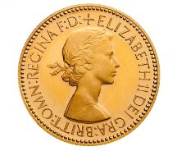__________
collection. She has got 85______________________ __________s.
Mr. Brown is 43 ______________________. He has got a 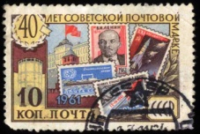___________
collection. He has got 98________________________ __________s.
Mrs. Smith is 35_____________________. She has got a ___________
collection. She has got 51__________________________ __________s.
I am ______________________. I have got a ____________________collection.
I have got ________________ __________s.

- Module 3. (стр.46)
В многоэтажном доме 20 этажей. Запиши, как ты спускаешься или поднимаешься на выделенные этажи. Используй образец.
20 | ↓ |  | ↓
 |  |  | 19
 | 17
 |  | 15
 | 13
 |  |  | 12
11
 |  | 8
 |  | 5
 |  |  | 4
3
↑ | 1 | ↑
Cround floor

1.I go upstairs to the third floor 2.__________________________________________________3.__________________________________________________4. I go downstairs to the seventeenth floor 5___________________________________________________6.__________________________________________________7.__________________________________________________8.__________________________________________________9.__________________________________________________10._________________________________________________11._________________________________________________12._________________________________________________

- Module 3. (стр.46)
Прочитай и нарисуй комнату по рассказу
It’s my bedroom. It is not very big, but it’s beautiful. Walls are orange. Floor is brown. There is a red carpet on the floor. I have got a desk, a coffee table, a bed, a wardrobe, an armchair and two chairs in my room. My bed is in front the wardrobe. There is a big bookcase next to the wardrobe. There is a coffee table next to the bed. There is a red lamp on the coffee table. The desk is next to the window. There is a computer on the desk. My brown armchair is next to the desk. My cat likes to sleep on it. There are two pictures on the wall. Can you draw my room?

MY ROOM

- Module 3. (стр.47)
При переезде грузчики неправильно расставили мебель и вещи. Расположи их в комнатах правильно.
living room  fridge bed  wardrobe sink | bedroom  cooker sofa  toilet washbasin
kitchen  bath chairs desk  armchair bookcase | bathroom  coffee table computer  table mirror

living room | bedroom
kitchen | bathroom

- Module 4. (стр.56)
Выбери правильное слово в скобках, чтобы описать людей на картинке

Mr. Green is (eleven, seventy, thirty).
He is a ( teacher, doctor, driver).
He is (strong, naughty, sweet).
He can ( play football, cook, speak Japanese).

Mr. Wilson is (eighteen, seven, fifty).
He is a ( businessman, wet, cook).
He is (clever, funny, strong). He likes (dogs, cats, birds).

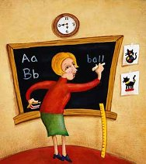
Mrs. Brown is (forty, ninety, thirteen).
She is a ( pilot, teacher, singer).
She is ( strong, naughty, clever).
She can( draw cats, run fast, play tennis).

- Module 4. (стр.58)
Сделай описание персонажей из мультфильмов по образцу

It is Daddy Smurf.
He is blue.
He is short and thin with a big nose and big eyes.
He has got a red hat.
He is clever


It is _________.
She is ___________.
She is _____and _______ with___________and___________.
She has got a ____________.
She is ________.

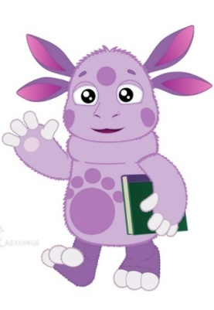
It is ____________.
He is__________.
He is _____ and ______ with _____________and __________.
He has got a ______________.
He is ________.


It is ____________.
He is__________.
He is _____ and ______ with _____________and __________.
He has got a ______________.
He is ________.
11) Module 5. (стр.68)
Соедини животное с его описанием
bear | has got a long tail
lion | has got big teeth
giraffe | has got big paws
monkey | has got a mane
peacock | has got a trunk
Crocodile | has got beautiful feathers
elephant | has got along neck

- Module 5. (стр.68)
Вставь пропущенные буквы запиши животных в таблицу
c…w b…ar s…eep p…g c…bra h…n c…mel g…ose hors… ele…hant m…nkey r…bbit tig…r du…k li…n giraff… sna…e go…t c…t d…er d…g goldfi…h t…rtoise b…dgie
pets | farm animals | wild animals
- Module 6. (стр.76)
Выставь правильное время на часах
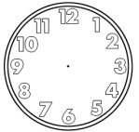 | It’s seven o’clock
 | It’s half past three
 | It’s quarter to eleven
 | It’s quarter past two
 | It’s half past ten
 | It’s quarter past six
 | It’s twelve o’clock
 | It’s half past nine
 | It’s quarter to eight

- Module 6. (стр.76)
Заполни пропуски и составь свой распорядок дня
On weekdays I ____________ at seven o’clock and my working day begins. I _______________ at quarter past seven. Then I __________________.
School starts at ______________________. I usually have six or five lessons a day. I go home at 2 o'clock and I______________________.
Then I do my homework and ___________________. My parents come home at 6 o'clock. We _______________________at ______________. After dinner I _____________________. I go to bed at____________________.
15) Module 5. (стр.68)
Найди профессии в кроссворде

b | t | e | a | h | o | d | a | d | m | a | n | a | t | s
o | f | a | n | i | c | e | l | t | e | a | c | h | e | r
a | g | p | t | t | s | r | l | o | m | r | h | t | s | p
s | a | n | e | a | i | c | e | a | v | e | r | g | x | i
a | r | o | a | x | d | r | i | m | u | x | p | h | u | s
d | p | d | e | i | s | b | d | o | c | t | o | r | o | r
o | a | g | v | d | e | a | y | d | e | k | s | i | n | e
m | i | e | o | r | w | k | h | e | a | v | t | h | p | t
a | n | a | s | i | a | o | u | w | r | a | m | t | m | e
n | t | t | p | v | i | n | r | a | e | g | a | g | a | r
f | e | i | m | e | t | s | b | t | a | e | n | a | d | b
a | r | c | o | r | e | c | o | o | d | b | a | k | e | r
t | c | s | l | s | r | n | r | e | h | i | j | o | t | m
o | s | e | a | t | m | e | c | h | a | n | i | c | e | a
m | t | w | i | l | t | o | r | d | w | k | a | h | r | n

Ответы
b | t | e | a | h | o | d | a | d | m | a | n | a | t | s
o | f | a | n | i | c | e | l | t | e | a | c | h | e | r
a | g | p | t | t | s | r | l | o | m | r | h | t | s | p
s | a | n | e | a | i | c | e | a | v | e | r | g | x | i
a | r | o | a | x | d | r | i | m | u | x | p | h | u | s
d | p | d | e | i | s | b | d | o | c | t | o | r | o | r
o | a | g | v | d | e | a | y | d | e | k | s | i | n | e
m | i | e | o | r | w | k | h | e | a | v | t | h | p | t
a | n | a | s | i | a | o | u | w | r | a | m | t | m | e
n | t | t | p | v | i | n | r | a | e | g | a | g | a | r
f | e | i | m | e | t | s | b | t | a | e | n | a | d | b
a | r | c | o | r | e | c | o | o | d | b | a | k | e | r
t | c | s | l | s | r | n | r | e | h | i | j | o | t | m
o | s | e | a | t | m | e | c | h | a | n | i | c | e | a
m | t | w | i | l | t | o | r | d | w | k | a | h | r | n

16) Module 7. (стр.86)
1.Расставьте в названиях месяцев буквы по порядку.
- U S A T G U
- M E D R C E B E
- R E Y U F A R B
- V O E B M E N R
- A L I R P
2. Вставьте пропущенные буквы.
- …an…ary
- Se…tem…er
- J…n…
- …ct…ber
- Ma…c…
3. Завершите предложения.
The month after May is … . - The month after May is June.
The month before October is … . – The month before October is September.
- The month after December is … .
- The month after March is … .
- The month after July is … .
- The month before September is … .
- The month before November is … .
- The month before May is … .

17) Module 7. (стр.88)
Прочитай и разукрась

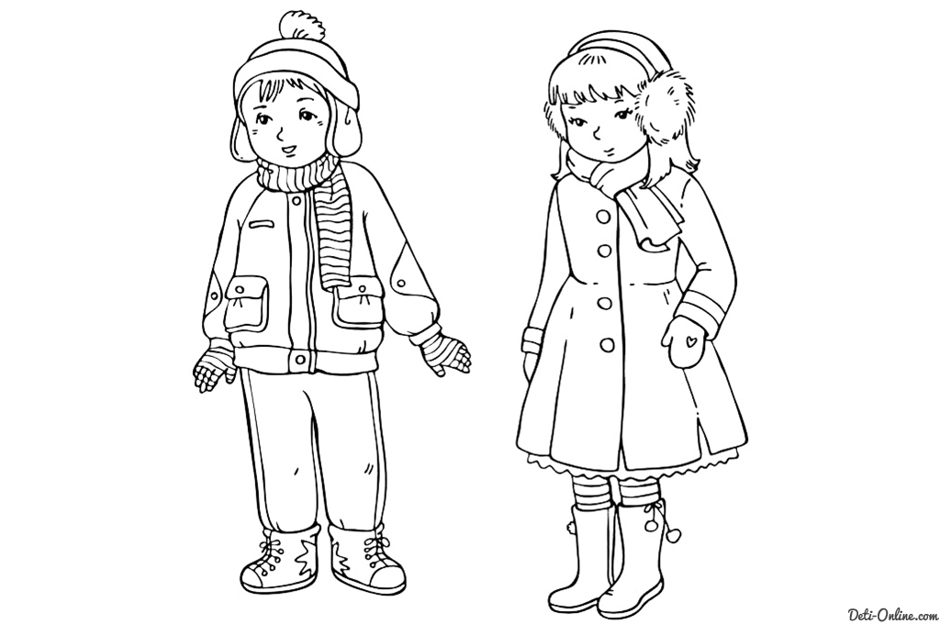

Ben’s jacket is green. Mary’s coat is pink.
Mary’s skirt is yellow. Ben’s trousers are grey.
Ben’s scarf is green and blue. Mary’s scarf is blue.
Ben’s trainers are grey and blue. Molly’s boots are black and white.
Mary’s gloves are red. Ben’s gloves are brown.
Ben’s hat is purple

18) Module 7. (стр.88)
Опиши картинки по образцу.

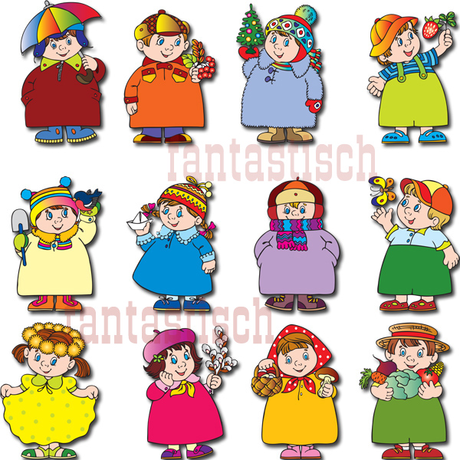
- The boy is wearing a brown coat, a blue hat and blue boots.
- ____________________________________________________________
- _____________________________________________________________
- _____________________________________________________________
- _____________________________________________________________
- _____________________________________________________________
- _____________________________________________________________
- _____________________________________________________________
- _____________________________________________________________
- _____________________________________________________________
- _____________________________________________________________
- _____________________________________________________________

19) Module 7. (стр.88)
Игра “Snake”
Найдите и запишите продукты, спрятанные в табличках.( Буквы расположены друг за другом ).
h | f |  | m | a | e | k | m |  | p
s | i | j | a | t | m | l | i | p | l
n | s | i | c | i | o | g | a | a | e
o | l | l | g | n | n | u | r | e | p
m | e | r | a | o | s | s |  | n | i
s | g | t | e | h | e | s |  |  | e
e | r | t | r | c | e | a | t | d | r
p | a | u | b | e | s | p | a | a | b

20) Module 7. (стр.88)
Рассмотрите таблицу и запишите по образцу
 | fish | rice | grape | meat | onions | garlic | pasta | cabbage
Bob | v |  | v |  | x | x
Ann |  | x |  | v | x |  | v
Sam | v |  | x |  |  | x |  | v
Kate |  | v |  | x |  |  | v | x
Bob likes fish and grape, but he doesn’t like onion and garlic.
____________________________________________________________________________________________________________________________________________________________________________________________________________

21) Module 9. (стр.106)
Вставьте слова и словосочетания в таблицу, чтобы получились предложения
At the Bakery | I can buy
At the Supermarket | I can buy
At the Cafe | I can order
At the Newsagent’s | I can buy
At the Florist’s | I can buy
At the Bookshop | I can buy
At the Art Gallery
At the Music Shop | I can buy
At the Clothes Shop | I can buy
At the Fast Food Restaurant | I can eat
At the Chemist’s | I can buy
At the Greengrocer’s | I can buy
At the Toy Shop | I can buy
At the Cinema | I can watch
At the Shoe Shop | I can buy

skirt, flowers, pictures, films, newspapers, s sugar, aspirin, bread, onions, trousers, pizza, doll, pasta, books, rice, CDs, magazines, boots, hotdog, postcards, chicken, trainers, pasta, vitamins, sculptures, tomatoes, teddy-bear
22) Module 10. (стр.117)
Прочитай обозначение и нарисуй знак
1. you can’t take dogs;
2. you can’t bathe;
3. you can’t ride a bike;
4. you can drink coffee;
5. you can buy souvenirs.
1. | 2. | 3. | 4. | 5.

