АВТОНОМНОЕ ОБРАЗОВАТЕЛЬНОЕ УЧРЕЖДЕНИЕ
СРЕДНЕГО ПРОФЕССИОНАЛЬНОГО ОБРАЗОВАНИЯ
РЕСПУБЛИКИ БУРЯТИЯ
«РЕСПУБЛИКАНСКИЙ МНОГОУРОВНЕВЫЙ КОЛЛЕДЖ»

АНГЛИЙСКИЙ ЯЗЫК ДЛЯ ДИЗАЙНЕРОВ

Приёмы актуализации профессиональной лексики

Учебное пособие по иностранному языку
Автор: Кожевникова ТП

г. УЛАН-УДЭ

2014г

Утверждено к печати Научно-Методическим советом
АОУ СПО «Республиканский многоуровневый колледж»

Рецензент: Хилханова Эржен Владимировна
Доктор филологических наук, профессор
кафедры иностранных языков и общей лингвистики
ФГБОУ ВПО
«Восточно - Сибирская государственная академия культуры и искусств»

Английский язык для дизайнеров: учебное пособие

В учебном пособии представлен дидактический материал с целью расширения запаса и активизации профессиональной лексики и развития навыков устной речи на профессиональном уровне.

Для студентов СПО по специальности «Дизайн»

ОГЛАВЛЕНИЕ:
стр
1. Введение
- Часть 1. Определение и характер работы дизайнера.
3. Часть 2. Одежда. Из истории одежды с 12-20 век
- Часть 3. Ткани: хлопок, шерсть, шелк. полиэстер
Свойства тканей
- Часть 4. Процесс пошива одежды. Требования к
Швее и портному. В швейной мастерской. Уход за
Швейной машиной. Инструкция по ТБ. Диалоги.
Ситуации
- Часть 5. Как стать дизайнером одежды. Ступени мастерства. Карьерный рост. Стили. Твой стиль
Одежды. Лучшие дизайнеры мира.
- Словарь специальных терминов
- Приложение. Тексты для чтения.

ВВЕДЕНИЕ

Дизайн-это процесс производства вещей,
мудрое и творческое решение
человеческих проблем
Брайан Хорриган

На протяжении многих лет, благодаря существованию «железного занавеса»выпускникам СПО было достаточно «читать и переводить со словарем» тексты на английском языке, но сегодня время требует совсем других навыков. В первую очередь, умения общаться с иностранцами не только на бытовые темы но и на своем профессиональном уровне ,на английском языке.
Одной из самых привлекательных профессий для нынешних выпускников школ является профессия «дизайнер», так как ее деятельность направлена на создание комфортной, эстетически оформленной среды обитания человека, его имиджа итд.
«Дизайн» в переводе с английского означает «замысел, проект. узор»( замышлять, проектировать) Исходя из этого , данное учебное пособие направлено на изучение : правил выполнения эскизов и моделей одежды, свойств различных видов ткани, истории одежды, различных видов швейного оборудования, технологии выполнения отдельных узлов одежды, соединение их в одно целое, ступеней становления дизайнера, различных стилей одежды и лучших дизайнеров мира.
Дидактический материал данного пособия подобран с целью расширения запаса профессиональной лексики и развития у студентов навыков устной речи на английском языке. Выбор текстов обусловлен определенной тематикой с профессиональной направленностью. Ввиду того, что студенты
имеют разный уровень знаний по английскому языку, тексты даны и простые и сложные, для перевода со словарем и без словаря. После текстов даны лексические, грамматические упражнения, направленные на расширение словарного запаса, его активизацию и развитие речевых навыков. Приведены упражнения для проверки понимания содержания текстов, а так же для тренировки лексического и грамматического материала.
Цели и задачи данного пособия – ввести и активизировать до уровня собственно высказывания лексику и терминологию связанную с деятельностью в области дизайна одежды, развить навыки разговорной речи по профессии на английском языке.
Тематически материал распределяется по 5 разделам , которые нацелены на изучение особенностей профессии «дизайн»: определение и характер работы дизайнера, история одежды, происхождение тканей, их свойства и уход за изделиями из них, требования к швее и портному, швейное оборудование, техника безопасности, ступени мастерства. карьерный рост дизайнера, стили и лучшие дизайнеры мира.

В процессе обучения студенты должны: знать:
- требования, предъявляемые к дизайнеру одежды
- историю одежды
- виды современных стилей
- свойства различных видов ткани
- технику безопасности при пошиве изделий
- швейное оборудование
Уметь:
- шить
- подбирать цвет, ткань
- определять стиль костюма Межпредметные связи:
Изобразительное искусство, биология, химия, технология, материаловедение.
Итоговый контроль осуществляется в форме защиты презентации

Тема рассчитана на 30 часов

UNIT I

DEFINITION AND NATURE OF WORK OF DESIGNER

Every shoe, piece of clothing, and accessory on every hanger and shelf at every store has been designed by a fashion designer. Fashion designers examine trends in the kinds of clothing people are wearing, draw designs based on their ideas, choose colors and fabrics, and supervise the production of their designs. Fashion designers may have a specialty, such as clothing design, footwear design, or accessory design. Accessories are items like handbags, scarves, belts, and hats.
A successful fashion designer must be good at predicting the future. Since it takes between eighteen and twenty-four months for an article of clothing to go from rough sketch to final production, the designer must understand buying trends as they are developing. Therefore, research on fashion trends is an important first step in the design process. Some designers do this research themselves, while others base their designs on research conducted by others, such as industry trade groups. Fashion designers go to trade shows or visit textile manufacturers to select fabrics for their designs.
When they have picked their fabrics and sketched their designs, fashion designers make prototypes of the clothing using inexpensive materials. These prototypes are tested on fashion models to see if any adjustments are needed. Some designs may be thrown out entirely and the line of clothing narrowed to fewer pieces. When the designs are finalized, samples of the item are made using the actual materials. These samples are taken to fashion shows or marketed directly to retailers.
In recent years, computers have changed the way many fashion designers do their work. Most designers still make their initial sketches by hand, but more and more are using computer-aided design (CAD) software to create designs that can be easily viewed from different angles in different colors on different virtual models. CAD also makes it easier to make adjustments to the original designs. So, a good fashion designer should possess a perfect knowledge of drawing, types of materials and their qualities, fashion and sewing skills

1. Find English equivalents to the fallowing words and word combinations:

1) каждая пара обуви 11) первый шаг в процессе
2) аксессуар дизайна
3) исследовать направления моды 12) производители тканей
4) выбирать цвета и ткани 13) проверять на моделях
5) рисовать эскизы 14) корректировка
6) наблюдать за производством 15) розничная продажа
7) успешный дизайнер 16) показ моды
8) предвидеть будущее 17) начальный набросок
9 черновой набросок 18) компьютерный дизайн
10) исследование направлений моды 19) виртуальные модели
2. Answer the following questions:
- What is usually designed by a fashion designer?
- What do designers usually examine, draw, and choose?
- What specialties can designers have?
- What a successful designer must be good at?
- What is the first step in the design process?
- What for the designers go to trade shows and textile manufacturers?
- When do the designers use inexpensive materials?
- What helps the designers in recent years?
- What knowledge should a good designer possess?

3.Speak about your future profession, using the questions, you have just answered, as a plan.

UNIT II

FROM THE HISTORY OF CLOTHING

Clothing is used to protect the body from the elements such as weather, the hot summer sun, extreme heat or cold, and rain. Clothing can also be a protective barrier from harmful chemicals, mosquitoes and other insects. Clothing has been used as a protection from weapons or injury to the body. Different types of clothing are worn to reflect religious beliefs. Throughout time man has devised clothing for nearly every situation, symbolizing different cultures, ceremonies, and social status.
The styles of clothes have changed throughout the centuries, from long restrictive dresses for women and suits for men with tails that almost dragged the ground. The clothing worn today is a lot more relaxed and the styles have evolved into what the wearer feel most comfortable in. The clothes worn at home is a lot more casual than the clothes worn to work, or out to a social event. Some people have to dress for their health and according to the climate. Everyone likes to wear beautiful clothes. Clothing that is no longer worn can be donated to the nearest Goodwill.
The first clothing was made from fur, leather, leaves and grass, wrapped and tied around and over the body for protection from the elements. Since fabrics decompose, there is little to go on as to how ancient garments looked. The discovery of sewing needles dating back to 30,000 BC leads archaeologists to believe that clothing was being made and worn.

Task: Agree or disagree with the following statements:

- Clothing is used only to protect the body
- The styles of clothes have chanced throughout the centuries
- Clothes worn at home and worn to work are casual.
- Everyone likes to wear beautiful clothes.
- Clothing that is no longer worn can be only thrown away.

CLOTHING IN THE MIDDLE AGES
In the 12th and 13th centuries clothes were still quite basic. In the Middle Ages men wore tunics. Some men wore shorts and all wore 'hose' (tights or stockings).
Women wore a nigh tie-like linen garment. However they did not wear knickers. They wore a long tunic (to their ankles) and over it another garment, a gown. Women held their dresses with a belt tied around their waists.
In the Middle Ages both sexes wore clothes made of wool but it varied in quality. Wool could be fine and expensive or coarse and cheap. From the mid-14th century laws lay down which materials the different classes could wear, to stop the middle classes dressing 'above themselves'. (Poor people could not afford to wear expensive cloth anyway!). However most people ignored the law and wore whatever clothes they wished.
In the late 14th and 15th centuries clothes became much more elaborate. Fashion in the modern sense began. For the wealthy styles changed rapidly. Women wore elaborate hats and men wore long shoes.
Poor people wore practical clothes. If it was wet and muddy they wore wooden clogs.

THE16-TH CENTURY CLOTHES
For rich Tudors fashion was important. Their clothes were very elaborate. For the poor clothes had to be hardwearing and practical. All classes wore wool. However it varied in quality. The rich wore fine quality wool. The poor wore coarse wool.
Linen was used to make shirts and underwear. However only the rich could afford cotton and silk clothes. Rich Tudors also embroidered their clothes with silk, gold or silver thread. Rich 16th century women wore silk stockings.
In the 16th century men wore short trouser-like garments called breeches. They also wore tight fitting jackets called doublets. Another jacket called a jerkin was worn over the doublet. Over the jerkin rich men wore a gown, or later in the 16th century a cloak or cape.
However instead of a doublet many workingmen wore a loose tunic. It was easier to work in. Some workingmen wore a leather jerkin called a buff-jerkin. Men also wore stockings or woolen socks, which were called hose.
In the 16th century women wore a kind of petticoat called a smock or shift or chemise made of linen or wool and a wool dress over it. A woman's dress was made of two parts, a bodice or corset like garment and a skirt. Sleeves were held on with laces and could be detached. Workingwomen wore a linen apron.
In the late 16th century many women wore a frame made of whale bone or wood under their dress called a farthingale. If they could not afford a farthingale women wore a padded roll around their waist called a bum roll.
In the 16th century women did not wear knickers. However men sometimes wore linen shorts.
In the 16th century everyone wore hats. Poor women often wore a linen cap called a coif. After 1572 by law all men except nobles had to wear a woolen cap on Sundays. This law was passed to give the wool cap makers plenty of work!
In the 16th century buttons were usually for decoration. Clothes were often held together with laces or pins. Furs in Tudor times included cat, rabbit, beaver, bear, badger and polecat.
The most expensive dyes were bright red, purple and indigo. Poor people often wore brown, yellow or blue. Incidentally in the 16th century scarlet was not a color it was the name of a fine, expensive wool.
Women who could afford it would hang a container of sweet smelling spices on their belt. This was called a pomander and it disguised the horrid smells in the streets! However it is a myth that in the 16th century people were very dirty and smelly. Most people tired to keep themselves clean but it was difficult to keep free of vermin. On the wreck of the Mary Rose many lice combs were found.
THE 17-TH CENTURY CLOTHES
At the beginning of the 17th century men wore starched collars called ruffs. Women wore frames made of wood or whalebone under their dresses. However the farthingale was soon discarded and the ruff evolved into a large lace collar (for those who could afford it!).
In the 17th century men wore knee length, trouser like garments called breeches. They also wore stockings and boots. On the upper body men wore linen shirts. In the early 17th century they wore a kind of jacket called a doublet with a cape on top. Men wore their hair long. They also wore beards.
In the late 17th century a man's doublet became a waistcoat and men wore a frock coat over it. With breeches it was rather like a three-piece suit. Men were now clean shaven and they wore wigs.
Women wore a linen like garment called a shift. Over it they wore long dresses. The dress was in two parts the bodice and the skirt. Sometimes women wore two skirts. The upper skirt was gathered up to reveal an underskirt.
From the mid 17th century it was the fashion for women to wear black patches on their faces such as little stars or crescent moons.

THE 18-TH CENTURY CLOTHES
. In the 18th century men wore knee-length trouser like garments called breeches and stockings. They also wore waistcoats and frock coats. They wore linen shirts. Both men and women wore wigs and for men three-cornered hats were popular. Men wore buckled shoes.
Women wore stays (a bodice with strips of whalebone) and hooped petticoats under their dresses. However in the 18th century women did not wear knickers.
Fashionable women carried folding fans. Fashion was very important for the wealthy but poor people's clothes hardly changed at all.

THE 19-TH CENTURY CLOTHES
In the 19th century, apart from cotton shirts, men’s clothes consisted of three parts. In the 18th century they wore knee length breeches but in the 19th century men wore trousers. They also wore waistcoats and coats.
In the early 19th century women wore light dresses. In the 1830s they had puffed sleeves. In the 1850s they wore frames of whalebone or steel wire called crinolines under their skirts. In the late 1860s Victorian women began to wear a kind of half crinoline. The front of the skirt was flat but it bulged outwards at the back. This was called a bustle and it disappeared in the 1890s.
From the 1840s onwards it was fashionable for women to have very small waists so they wore corsets.
About 1800 women started wearing underwear. They were called drawers. Originally women wore a pair of drawers i.e. they were actually two garments, one for each leg, tied together at the top. In the late 19th century women's drawers were called knickerbockers then just knickers.
In the 19th century people of all classes wore hats. Wealthy men wore top hats. Middle class men wore bowler hats and working men wore cloth caps.
Before the 19th century children were always dressed like little adults. In that century the first clothes made especially for children appeared such as sailor suits.
A number of inventions to do with clothes were made in the 19th century. The safety pin was invented in 1849. The electric iron was invented by Henry Seely in 1882 but it did not become common until the 1930s. Dry cleaning was invented in 1855. The zip fastener was invented in 1893. Meanwhile in 1863 Butterick made the first paper dress pattern.

THE 20-TH CENTURY CLOTHES
At the beginning of the 20th century fashionable men wore trousers, waistcoat and coat. They wore top hats.
In 1900 women wore long dresses. It was not acceptable for women to show their legs. From 1910 women wore hobble skirts. They were so narrow women could only 'hobble' along while wearing them. However during World War I women’s clothes became more practical.
In the early 1920s women still wore knickers that ended below the knee. However during the 1920s knickers became much shorter. By the late 1920s they ended well above the knee. In the mid-20th century younger women wore briefs.
A revolution in women’s clothes occurred in 1925. At that time women began wearing knee length skirts. In the mid and late 1920s it was fashionable for women to look boyish. However in the 1930s women’s dress became more conservative.
During World War II it was necessary to save material so skirts were shorter. In Britain clothes were rationed from 1941 until 1949.
Meanwhile the bikini was invented in 1946. In 1947 Christian Dior introduced the New Look, with long skirts and narrow waists giving an 'hour glass' figure.
During the 1950s women's clothes were full and feminine. However in 1965 Mary Quant invented the mini skirt and clothes became even more informal.
After the First World War men’s clothes became less informal and more casual. In the 1920s wide trousers called 'Oxford bags' were fashionable. Men also often wore pullovers instead of waistcoats.
In the 19th century men's underwear covered almost the whole body, stretching from the ankles to the neck and the wrists. However in the 1920s they began to wear shorts that ended above the knee and sleeveless vests. The first y-fronts went on sale in the mid-1930s.
In the second half of the 20th century clothes for both sexes became so varied and fashion changed so rapidly it would take too long to list them all. One of the biggest changes was the availability of artificial fibers. Nylon was first made in 1935 by Wallace Carothers and polyester was invented in 1941. It became common in the 1950s. Vinyl (a substitute for leather) was invented in 1924. Trainers were designed in 1949 by Adolf Dasler.

UNIT III

TEXTILES

A textile is a cloth, which is either woven by hand or machine. "Textile" has traditionally meant, "a woven fabric". The term comes from the Latin word texere, meaning to weave.
Fibers are the raw materials for all fabrics. Some fibers occur in nature as fine strands that can be twisted into yarns. These natural fibers come from plants, animals, and minerals. For most of history, people had only natural fibers to use in making cloth. But modern science has learned how to produce fibers by chemical and technical means.

COTTON

Cotton is a soft white fibrous substance covering seeds of certain plants.
Forty centuries ago cotton was used in China to make both cool summer clothes and warm winter ones.
When first brought into Europe cotton was sold not as a cheap common stuff, but as a rare fabric. Only the rich could have it. Now cotton is very popular. Many garments, such as shirts, blouses, skirts, dresses, trousers, bermudas, pants, bedspreads, pillowcases, carpets, curtains are made of cotton.

Answer the following questions:

- Where was cotton used first?
- What was made out of cotton in China?
- Was cotton cheap or expensive in Europe?
- Who could buy cotton?
- Is cotton expensive now?
- What garments are made of cotton?
- In what countries grow cotton?

Properties of the cotton:
1)It is soft and comfortable.
2)It wrinkles easily.
3)It absorbs perspiration quickly.
4)It has good colour retention and is good to print on.
5)Cotton is also strong and durable.

WOOL
Woolen fabric is made from the fleece of sheep and goats

WOOL IN ENGLAND

The art of wool weaving is known to come to the British Isles from the Romans. In the 4th century of our era Roman soldiers in Great Britain started a wool-weaving factory at the British town of Winchester, to supply themselves with clothing. It is from this factory that the native population of Great Britain learned to weave wool.
Later Britain became famous for wool, at first it was a large exporter of raw wool and then it became an exporter of woolen textiles.
1. Answer the following questions:

1)Where from did the art of wool-weaving come?
- When did the Romans start a wool-weaving factory in Britain?
- Why did they start it?
- How did the native population learn to weave wool?
- How was wool exported at first and later?

2.Check the following questions:

- The art of weaving came to Great Britain from India
- The Roman soldiers started a wool-weaving factory in London
- The native population learned to weave wool from Indian weavers
- Nowadays Britain exports only raw wool

PROPERTIES OF THE WOOL

1)It is hard wearing and absorbs moisture.
2)It does not burn over a flame but smoulders instead.
3)It is lightweight and versatile.
4)Wool does not wrinkle easily.
5)It is resistant to dirt and wear and tear.

SILK

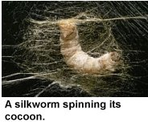
Silk is the fine strong soft lustrous fiber produced by silkworms The Chinese has used silk since the 27th century B.C.. Silk is mentioned by Aristotle and became a valuable commodity both in Greece and Rome. During the Roman Empire, silk was sold for its weight in gold. The Chinese domesticated silk worms and fed them with mulberry leaves. They unwound the silkworms' cocoons to produce long strands of silk fiber.

A LEGEND OF THE HISTORY OF SILK

Silk was brought into Persia by a Chinese princess. This princess was to marry a Persian prince. She decided to take all her riches to Persia and among them some of the silkworm eggs. She told nobody about it and took some silkworm eggs and put them into a little black silk bag and hid them in her hair. She knew that the price of these little eggs was as high as all her riches. As soon as the bride reached Persia she could explain how silk was made and in that way the Persian weavers learned the secret of weaving silk.

Упражнения
1. Answer the following questions:

1)How was silk brought to Persia?
2)What did the bride decide to take to Persia?
3)How did she hide the silkworm eggs?
4)How did she teach the Persian weavers to weave silk?

2. Make up a story using the following key-words:
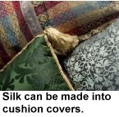
was brought; was to marry; decided to take; told nobody; could explain; took; put; hid; learned
Properties of the silk:
1) It is versatile and very comfortable.
2)It absorbs moisture.
3)It is cool to wear in the summer yet warm to wear in winter.
4)It can be easily dyed.
5)It retains its shape and is relatively smooth.
6)It has a poor resistance to sunlight exposure.
7)It is the strongest natural fiber and is lustrous.

NYLON
.
Nylon is a strong, light synthetic fiber. It is a man-made.
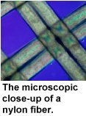
History of the use of nylon:
This synthetic fiber was introduced in the 1930s. It was another early substitute for silk and soon quickly became the fiber of choice for women's stockings. The first commercial production of nylon in the United States was in 1939 by the E.I. du Pont de Nemours and Company.
Wallace H. Carothers, a chemist of the Dupont Company played the leader in this development of nylon. This man-made fiber is the second most used fiber in the United States.
Properties of the nylon:

1)It is strong and elastic.
2)It is easy to launder.
3)It dries quickly.
4)It retains its shape.
Uses:
Nylon is popular for hosiery and is used to make track pants, shorts, swimwear, active wear, windbreakers, bedspread draperies. It can also be made into parachutes, flak vests, combat uniforms, tires and life vests, or used as the netting of bridal veils, umbrellas and luggage.

POLYESTER

Polyester is the general name for any group of widely used synthetic products. Polyesters are strong, tough materials that are manufactured in a variety of colours, shapes and sizes.
The first commercial production of polyester was by the du Pont de Nemours Company. It is the most used fibre in the United States.
Polyesters are made from chemical substances found mainly in petroluem. Polyesters are manufactured in three basic forms -fibers, films and plastics.
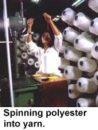
Polyester fibers are used to make fabrics. Poly (ethylene terephthalate, or simply PET) is the most common polyester used for fiber purposes. This is the polymer used for making soft drink bottles. Recycling PET by re-melting it and extruding it as fiber saves much raw materials as well as energy.
PET is made by ethylene glycol with either terephthalic acid or its methyl ester in the presence of an antimony catalyst. In order to achieve high molecular weights needed to form useful fibers, the reaction has to be carried out at high temperature and in a vacuum.
Care of your polyester garment:
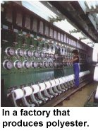
1) Machine-wash your fabric in cold water.
2) Wash with light colours.
3) Use a gentle cycle while washing.
4) Tumble dry with the setting low.
5) Do not bleach.
6) If needed, iron with a cool iron.

Properties of the polyester:
1)It resists wrinkling.
2)It is easy to launder.
3)It dries quickly.
4)It is resistant to stretching and shrinking.
Uses:
Polyester is used to make most forms of clothing like shirts, running shorts, track pants, windbreakers, and lingerie. It can also be made into curtains and draperies.

UNIT IV

THE PROCESS OF TAILORING GARMENT

Like it or not, to design clothes you have to learn how to sew. Even though you can teach yourself, for the best results, you may want to take a sewing class. Make sure to learn how to sew by hand and how to use a sewing machine.

1.Guess the meaning of the words and word combinations and read the text:

Rational methods instruction
mass production assortment
individual production operation
regulating function
temperature system
self-control defects
process progress
organization

THE REQUIREMENTS TO A SEWER OR A TAILOR

A sewer or a tailor should know how:

- to make garments to measure;
- to use rational methods of dress-making or tailoring for mass production;
- to make proper use of all the tools and equipments;
- to take the proper care of the sewing machines (cleaning, oiling, threading, regulating);
- to determine the temperature of the iron;
- to check the condition of the sewing machines, tools and irons;
- to determine the quality of cutting of all the parts and of the finished garment;
- to prepare the garment for fitting;
- to realize self-control in the process of making up clothes;
- to apply the progressive methods of the organization of work;
- to follow the instruction on accident prevention

A tailor should possess a sound knowledge of:

- assortment of clothes;
- methods and ways of making the machine , handwork and pressing operations and requirements to their quality;
- terms of handwork, machine and pressing operations;
- chalk signs and marks on the parts of the garment after the fitting;
- kinds of materials and their main qualities;
- arrangement and functions of all the tools, irons ,sewing machines;
- main kinds of defects of the garments, their causes and measures to remove them

2. Finish the following sentences;
1) A tailor should know how…
2) A tailor should possess a sound knowledge of…

3. Read the text and compose your own story about your workshop:

IN THE WORKSHOP

In every workshop there are long working tables. They are covered with plastic to be smooth and even. At the tables there are rocking –chairs which can be lowered or lifted.
A student can either sit on the rocking chair or stand at the table when he works. At the working place of every student you can see a tool-box. In the tool-box students keep: bobbin, bobbin-case, chalk, scissors, measuring-tape, needles, thimble, threads of different colors.
At the wall there are some ironing –boards on which students can press and iron the pieces or the whole garments.

This questions will help you:

- Where is your workshop?
- What tables are there?
- What is there on the working place of every student?
- What do they keep in their tool - boxes?
- How many sewing machines have you got?
- How many ironing- boards are there in your workshop?
- What can you do on the ironing – boards?
- Do you like to have practice in your workshop?

4. Find in the text English equivalents to the Russian words:
правая (лицевая) сторона, повреждение, утюжить, гладильная доска, изнаночная сторона. блеск, утюг, проутюжельник

PRESSING

Pressing is a basic part of sewing. It is not the same as ironing because when pressing pressure and steam do the work.
The process is principally one of lifting the iron and putting it on a damp cloth. Make certain that your ironing-board is smooth, soft and well-padded. Except for ordinary cottons and linens press everything on the wrong side. Woolens, silks and rayon will require a press cloth between the iron and material.
Rayon require very little heat and may be damaged by a hot iron. Silks may take a slightly higher temperature cottons, woolens and linens require a hot iron. Always press lightly to avoid causing a shine. If a shine does appear, it can be usually removed by rubbing with a rough damp cloth.
When the garment is finished, give it a final pressing.

4. Расскажите, какова должна быть температура утюга в зависимости от ткани, из которой сшито изделие.

5.Make up 10 questions to the text:

CARE OF SEWING-MACHINE
То get the best results from any machine it is necessary' to give it proper care. This consists of cleaning and oiling. If it is not kept clean and oiled it runs heavily. It is necessary to brush the dust from all parts. Before cleaning it is wise to remove the needle to avoid the danger of sewing into the finger. The motor of the sewing-machine also requires oiling. All dust and dirt can be removed by wiping the parts out with the cloth. All parts of friction on the machine should be oiled too

- Find in the text English equivalents to the Russian words and expressions:

Разбросанные иглы, спецодежда, порядок, ручная работа, наперсток, нарушать правила, плохое содержание, размахивать руками, ножницы, край стола, неисправный, выключать, смазывать

INSTRUCTION ON ACCIDENT PREVENTION

Cause of accident:

- ignorance of dangerous places of equipment;
- breaking the rules of wearing clothes;
- wrong keeping of the sewing-machine;
- needles thrown everywhere

. Duties before starting work:

- put on your overall;
- put the kerchief over your hair;
- check the tools;
- put your working place in order, prepare it for work, take away all the unnecessary things.

During the work:

- don't sit on the working table;
- when working with a needle be sure to put a thimble;
- don’t put needles in your overall;
- don't wave hands about with the needle;
- don't put scissors into your pockets, put them far from the table edge, check the scissors not to fall on the floor.
- after work take all the tools away and put your working place in order
.
Working with a sewing-machine:

- put your overall, avoiding the hanging ends that may find themselves in the machine;
- before setting the machine in motion control it. If the sewing-machine. is out of order call the mechanic;
- don't talk while working;
- mind your fingers out of the needle;
- don't hold the fingers of the left hand close to the foot of the machine, and of the right hand close to the needle;
- don't elbow the sewing-machine.

After work:

- stop the sewing-machine and switch off the motor;
- put the working place in order;
- clean and oil the machine

.

7. Retell the text according to the plan. Start with:

1)The accident causes…
2)Before starting work you must…
3)During the work don’t…
4)Working with the sewing mashine…
5)After work…

- Read and translate the text:

LADY’S CLOTHES

Jane tells about her clothes
In the morning I generally wear a blouse and skirt or a jumper and a skirt, especially in winter. In spring or summer I like something lighter and 1 wear a cotton or a linen frock and a hat to match. In the evenings I like to dress for dinner especially if I am going out to a theatre or dance. My favourite is a black evening dress, beautifully cut. With this dress I wear pearl earrings and a necklace of pearls.
For tennis I wear a short white linen dress and for a seaside a beach dress.

9. Answer the question and ask the question to your neighbour
Example: A.: What does Jane wear in the morning?

В.: Jane wears a blouse and skirt in the morning. And you? What do you wear in the morning

A.:I wear a dress or a jumper and a skirt

1)What does Jane wear in spring or summer?
2)What does she put on in the evening?
3)What's her favorite dress?
4)What does she wear for sports?

10. Make up sentences using a table:

I  She  Jane  You  He  They | like to wear  likes to wear | a long dress  a linen dress  a coat and a hat  a skirt and  a blouse  a costume  pajamas  knitted dress | in the morning  for sports  in winter  in summer  at school  at night

11. Answer the following questions:

What do you usually wear | In the morning  in winter  in summer  when it rains  for sports  to the theatre  at school  to the park

12. Read the texts and guess the meaning of the unknown words without using dictionary:
ABOUT NEEDLES
Needles were made at first of different materials: of horse and fish bones, bronze. Steel needles were introduced into Europe by the Arabs and made in Europe in the fourteenth century. There are different kinds of needles for different uses: with long and small eyes short and long needles. There are special needles for sewing-machines.

BUTTONS
The selection of buttons depends on the type of dress and the material of which it is made. There should be harmony between the texture and color of the buttons and the dress fabric. Buttons with shanks are often used for decorative purposes, as the flat buttons with eyes.
It is possible to sew buttons on with coloured thread to carry out some special colour scheme. The button-hole should be worked before the buttons are sewed on, as this makes it easier to mark the position for the buttons.

POCKETS
Pockets are often useful as well as decorative. There are two different kindsof pockets: patch pockets and set-in pockets. A patch pocket is made by sewing a shaped piece of material to the outside of the garment. A set-in pocket is sewed into a slit in the garment. The edges of the slit may be finished in several different ways. The position, size and shape of the pocket are planned in relation to the rest of the dress.

DIALOGUES

13. Read, translate and reproduce the dialogues:

1. Mother: Take off your shirt. It's rather dirty. And besides, two buttons are missing.
Nick: All right, Mum. I'll put on another shirt. A blue one.

2. Mother: Put on your fur cap, Nick. It is very cold outside.
N i с к: Good, Mother. But I can't find it anywhere.
Mother: It's in the wardrobe on the upper shelf.

3. Peter: I say, Mother. This shirt is too small for me.
Mother: Let me see. Yes, it is small. Try on another one. And I'll make this one fuller.

4. Kate: I think the dress sits badly.
Ann: What's the matter with it?
Kate: It sits in wrinkles at the back. You must let it out there.
Ann: Shall I reduce it?
Kate: Certainly. And besides, trim it with lace at the neck.

5. A.: That's a lovely jacket!
В.: You think so? Thank you, I myself like it so much, especially when I
wear it in spring.
A.: And it's becoming your very much, too.
В.: So it is, thank you. I think it's very much in fashion, isn't it?
A.: The style is so good that it seems to be always in fashion.

6. — The skirt seems rather long, doesn't it?
- I wouldn't say that. Look at yourself in the mirror.
- But I'm just standing in front of it. For sure, the skirt's too long.
- All right, then. It's not difficult to make it shorter after all.

SITUATIONS

7.You exchange remarks with your friend what colour becomes you:

— Why do you keep to yellow (black, red, blue)? This colour doesn't suit you very well.
— But its in fashion now ( my favorite colour, very popular now, in style)

8.Having visited a fashion-show you tell your friend about it.
Midi-skirts  double breasted coats  long dresses  silver fox  coats with lapels  big patch pockets  mini-skirts  tight-leg trousers  shirt-like dresses | come  is  are | in fashion now.  all the fashion now.  very popular nowadays  in style  out of fashion

9. Complete the following sentences
It's raining hard.
It's very cold out ...
It's damp and windy out s shining brightly I'd better put on …
There's much snow in the streets
It's rather frosty outside

10. Make up sentences using a table:.

1)-You are dressed too thinly. It's rather frosty outside
lightly windy
thickly warm
warmly hot

- Is it? I'll change into my warm overcoat.
fur coat
woolen suit
blue costume

11. Having received an invitation to a party, you discuss at home what to put on:

1)- Do you think this tie will go well with my jacket?
blouse skirt
scarf dress

- Yes, they match perfectly well.

2) -Shall I put my long black dress or a pink one?
- The pink one. It's becoming you very much.

12 Read and translate the text using a dictionary:

A TEXT
(from I. Galsworthy)

She opened the parcel. A blue suit, a velour hat, some brown shoes, three pairs of socks with two holes in them, four shirts only a little frayed at the cuffs, two black-and-white ties, six collars not too new, some handkerchiefs, and a brown overcoat with a belt and just two or three nice little stains.
She held the blue suit up against her arms and legs; the trousers and sleeves would only need taking in about two inches. She put those things aside, and turned to the other things. A brown knitted dress with little clear yellow buttons. A brown hat with little golden-brown feathers. Two pairs of brown stockings, brown shoes; two slips. A white silk jumper with a hole in one sleeve, a skirt, and almost black-brown coat, long and warm, with great buttons and in the pocket six small handkerchiefs.

13. Test yourself:

1).The tables in your workshop are covered with…….. to be smooth and even
a. paper b. cloth c. plastic d. metal
2) The students cannot keep…….. in their tool-boxes
a. chalk b.thimble c. iron d. measuring tape
3)To get the best results from any machine it is necessary to give her proper………
a. love b. care c. food d. water
4) In cold countries the first garments were …….
a. cotton jackets b. skins of animals c. silk dresses d. wool dresses
5)Silk was born in……
a. Persia b. China c. America d. Russia
6) Silk was brought to Persia by……
a. Chinese soldiers b. Chinese princess c. English people d. Romans
7) The Chinese princess hid silkworm eggs in her….
a. dress b. hair c. shoes d. car
8) The art of wool weaving came to England from…..
a. the Americans b. the Russians c. the Romans d. the Indians
9) Cotton was born in…….
a. Russia b. Italy c. China d. England
10) The first needles were made of…..
a. fish bones b. wood c. plastic d. metal
11) There are ………needles for sewing machines
a. wooden b. plastic c. special d. ordinary
12) If the sewing machine is out of order…
a) press it b) oil it c) call the mechanic d) take the needle away

UNIT V

- HOW TO BECOME A FASHION DESIGNER?


Sometimes fashion designing sounds like a dream job, right? Unfortunately, it can also be one of the hardest professions to get into. However, with hard work, it can be done. There are many types of fashion designers. Some work for themselves, others work at normal sized companies, and others work for international businesses. Below are the steps to becoming a great fashion designer. So if you want to become a fashion designer, read on! But remember, it may take 3 to 4 years, so be patient.

STEPS:

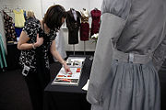
Keep a research journal. Also write what type of fashion each company makes. These are called "fashion categories". Some examples of categories are: footwear, accessories, junior wear, and career wear. Decide what category interests you the most

Start a style file or portfolio with pictures of that type of fashion. If you want to add sketches, that will only add to your notebook. Make a list of companies or brands in that category, as well as your favorite and most inspirational designers

Keep fashion inspiration. Buy a simple cork board and paste, pin, and tack inspirational fashion pictures on it. Put it up somewhere where you will constantly see it, like your bedroom or a 'studio room' if you have one. Buy some folders and file fashion magazine clippings or computer print outs in it. Subscribe to fashion magazines like Vogue or Teen Vogue and stay on top of the latest trends. Keep a little book of fashion cuttings in your bag or purse. If you're constantly surrounded by fashion inspiration, the ideas will come flooding in. But remember - don't ever copy a fashion piece. Just be inspired to create your own.

Take an art class in drawing and sketching. Learn to draw drapery, to understand the flow of fabric (how it drapes). You'll start to notice the dark areas in the folds, and the lighter highlighted areas. If you can find a class that draws people or "life drawing", take that too. If you can't draw real people, start drawing from photos. Use tracing paper to trace over the pictures of fashion models. Then slim then even more and elongate them for dramatic effect. Also learn about color, and mixing color. Know what colors look good together and how color groups are assembled. Focus on drawing actual fashions, and perfecting drawing bodies

Get a mannequin that you can pin fabric on, or drape to make designs to see how they would fit a body. Draping is another word for covering, dressing, or hanging cloth in loose folds. You can learn about this in a sewing class, or through a fashion school or program. Also, if you want to enter a fashion design college but you aren't the greatest at making sketches to add to your portfolio, it's always acceptable to just pin clothing you have designed and sewed onto your mannequin and take pictures of it

Learn to sew clothes. Take a sewing or dressmaking class. Study the patterns and become familiar with sewing pattern shapes. Sew for real people (like family and friends) so that you get familiar with body shapes and fit. Also learn about fabric. Know what fabrics are made from (silk? wool? cotton?) and how they are woven (velvet, twill, satin). Know which types of fabrics are best for each of your designs (stiff fabric, drapey fabric, sheer fabric, etc

Make clothes for other people. You will learn a great deal about dealing with a customer and fitting the human body in all its variations (tall, short, petite or large). You can also charge money for your work

Learn about fashion trends. Visit web sites such as pantone.com to see what colors are going to be in fashion. Also try to predict what fashion will be popular in the future. Check out sites like elle.com or style.com

Learn how fashion is sold. Is it being sold in stores or online? What are the major department stores? What stores sell the category of fashion you are interested in? Also learn about "targeting your customer base." This means knowing the type of person who will buy your fashions

Get professional training. Many places have public colleges or trade schools with excellent fashion training. Research it. See if schools in your area have a program in fashion. Plan to spend at least 1 to 2 years in any fashion design program. Don't feel that you have to spend a lot of money to get this training

Portfolio and Resume: When you graduate, you should have a portfolio of your best work. Usually these illustrations are of the one category that you are interested in finding a job in. A good portfolio should hold all your sketches and then you will be able have an interview and showing your designs to the interviewers. A good size for a portfolio is 14" x 17

First job. Think of your first job as 'graduate school'. You won't be the head designer yet, but you might work for him/her. It will be hard work, long hours, and lots of exciting times. As you work, you will move up the career ladder, working at many positions and gaining valuable industry experience

1)How to become a fashion designer, what are the main steps?

2)Study the following six clothing styles and determine your own style:

Clothing Styles

HERE ARE SIX CLOTHING STYLES

CLASSIC | Clothing: Elegant, refined, fashionable, dignified, clean simple lines, softly tailored or soft flowing, ensemble dressing, not usually mix and match. Never trendy, faddish or severe in style. No crisp, bouffant lines.  Fabrics: Matte finished or low luster's dominate this wardrobe. Look of richness and quality and moderate weights. Refined textures such as silk, soft woolen fabrics, cotton, smooth knits, solid colors best.  Evening wear: Chiffon or elegantly beaded fabrics.  Prints: Evenly placed and easy to look at prints, soft flowing abstracts, hounds tooth checks, herringbone patterns.  Accessories: Refined, elegant, and fashionable. Sleek, slightly chunky, smooth circle or geometric, no angles  Personality Profile: Emotional nature, balanced, controlled and rational. Old fashioned person and home body.  Work Environment: Management or administrative work
ROMANTIC | Clothing: Rounded lines, lots of draping of fabrics, flowing shapes in dresses with a waistline. Waist definition, with soft, ornate feminine lines. Fluidity of line from head to toe.  Fabrics: Light to medium weight, rich and Lucas, silk and soft woolens, sweater knits, suedes. drapy fabrics.  Evening wear: Velvet, chiffon or lace.  Prints: Oversized florals, polka dots, feathery shapes  Accessories: Dainty jewelry in detail but lavish. Ornate evening wear, diamonds, silk scarves and flowers.  Personality Profile: Artistic, charming enchanting and magnetic.  Work Environment: Advertising, Recruiting
INGENUE | Clothing: Frilly frocks of tucks, ruffles and lace. Old fashioned feminine styles, Victorian looks, simple clothes in feminine fabrics.  Fabrics: Lightweight, soft woolens, angora, cashmere, fine silk, fine cotton, crisp cotton, gauze or knit.  Evening wear: Chiffon, organza, eyelet, open crochet knits  Prints: Prints & florals, from small to large.  Accessories: Dainty jewelry in detail but lavish. Ornate evening wear, diamonds, silk scarves and flowers.  Personality Profile: Like Romantic  Work Environment: Decorator
DRAMATIC | Clothing: Long, sleek, and always straight lines. High fashion, severely tailored garments. Square, sharp shoulders lines, angular necklines, shapes and edges. Extreme, exotic dress for evening. Ensemble looks, no mix or match separates.  Fabrics: Fabrics hold defined shapes. Gabardine, stiff brocade, or metallics. Patterns are bold and sweeping abstracts or geometrics in bold colors. Head to toe dark neutrals or bold colors.  Accessories: Bold jewelry, sleek and elegant. Hats, belts, bags and shoes with angular shapes.  Personality Profile: Natural authority, in control, risk taker.  Work Environment: Business Owner
NATURAL | Clothing: Softly tailored, unstructured garments. Nothing fussy or frilly or fitted. Minimal details, loose garments for mobility. Separates dominate, mix and match, designer sportswear.  Evening: Sheath or strapless gowns, sarongs, jersey cocktail dresses.  Fabrics: Soft textures, rough or nubby fabrics. Knits, matte finishes.  Evening wear: Smooth to somewhat plush, metallics, and glitzy fabrics.  Accessories: Minimal jewelry, simple chains and stud earrings, may be chunky or funky. Earth or Indian jewelry.  Personality Profile: Warm and friendly, goal oriented, responsible.  Work Environment: Homemaker or business team player.
GAMIN | Clothing: Very tailored, straight, sharp fine lines. Animated outline, snappy, chic, lots of crisp trims of contrast, braiding or beads. Eye-catching detail.  Fabrics: Colorful, bold and sassy. Multicolor, animated, defined in shape, easily tailored, matte finishes light to moderate weights, oriental silks, crisp cottons, wool, etc.  Evening wear: Sleek, crisp trims, tailored edges, angular necklines, asymmetrical hemlines, beading, metallics.  Prints: Smart, colorful, animated, contemporary in look.  Accessories: Small, crisp, geometric and colorful. Tailored, contrasting dresser, dark hosiery should be sheer.  Jewelry: Small and geometric, asymmetrical or irregular shapes. Contemporary and trendy looks.  Personality Profile: Energetic, drive, spunk. Dynamic, charming personality. Fast mover.  Work Environment: Sales, Marketing, Real Estate and Public Relations.

Mixed clothing styles:

Classic with Dramatic, Classic with Romantic,
Romantic with Dramatic, Dramatic with Romantic,
Natural with Dramatic, Gamin with Dramatic,
Gamin with Romantic.

  - What is your clothing style? (your mother’s, sister’s, friend’s)

3. Read the text and answer the questions:

FASHION AND MY STYLE OF CLOTHES

Fashion is a thing that we have to keep up with, whether you like it or not. Anyway it’s important to look attractive. But it doesn’t mean that you should be a fashion-conscious. It may turn to a waste of money. If a person doesn’t have good taste he is not able to put things together. Trendy people want to stand out in a crowd, but sometimes they don’t look stylish.
First of all, think what clothes should suit you. If you have good taste you can buy a big range of styles and always look fashionable. But clothes should suit the occasion, and put you in the right mood for the day. But there are people who are not able bothered about fashion, they just want to stand out in a crowd by wearing something unusual, old-fashioned or trendy. Actually, I’m not such a person and I guess you should choose things according to your personality and character, and you’ll look well-dressed even if you wear something casual.
I like wearing different kinds of clothes, but certainly clothes should suit the occasion. When I plan what I’m going to wear I usually think what kind of meeting I have. At school we weren’t allowed to wear sport or bright clothes, we had to wear clothes of formal style. Usually I wore a jacket, a blouse and trousers or a skirt. But I didn’t like being dressed that way, as many other students. Really I prefer smart clothes to formal. Besides I enjoy wearing sport clothes, because I feel comfortable in it. Also on my list of likes there are jeans. One of my favorite colors is white, so I like white sweaters, tops and skirts. I usually wear high heeled shoes even if it’s not always comfortable or thick-soled boots. When I go out I always dress up, because I feel better that way. But when I have an official meeting I try to wear formal clothes.

1)Is it important to look attractive?
2) What may turn to waste of money?
3)Who wants to stand out of crowd?
4)What is the first step in choosing clothes?
5)What should clothes suit?
6)According to what should you choose clothes?

What clothes do you prefer?

4. GET AQUAINTED WITH THE BEST DESIGNERS OF THE WORLD:

ARMANI- the master of elegance. One of best Giorgio Armani phrases to describe his point of view: "when I think about elegance, I think of how one achieves it only by silencing loud trends." Goods under his brand are not changing drastically every season - the same elegant and tailored style flows from line to line, taking the best current cultural news. Clothing fashion always leaves a lot of space for interpretation of the man who wears it. Style is not created by Armani; style is your own luxury created by using Armani


VERSACE- the master of luxury. As all other most famous designer brands, Versace has a few design lines and some of them are orientated at casual men and women apparel, but he is much more known as a creator of marvelous and eye-catching luxury jewelry, apparel and accessories designs. Many most famous world actors, music stars and other celebrities wear Versace, because of the style that makes a person the center of attention, who always looks exceptionally great, fashionable, stylish, sexy and classy

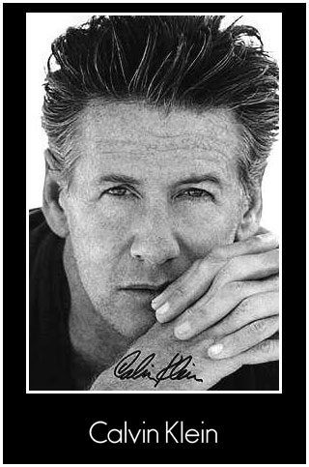
CALVIN KLEIN - the master of urban and sophisticated style. One of the main ideas of this designer - less looks more. He always stays with the same vision: "I've always had a clear design philosophy and point of view about being modern, sophisticated, sexy, clean and minimal." Calvin Klein is one of the best known designer brands of the world and all this was reached because of his unique style orientated at practical design clothes without exaggerating jewelry and other accessories. He was the first designer who created unisex fragrance "CK One" and the first line of designer jeans is also under the label of Calvin Klein.

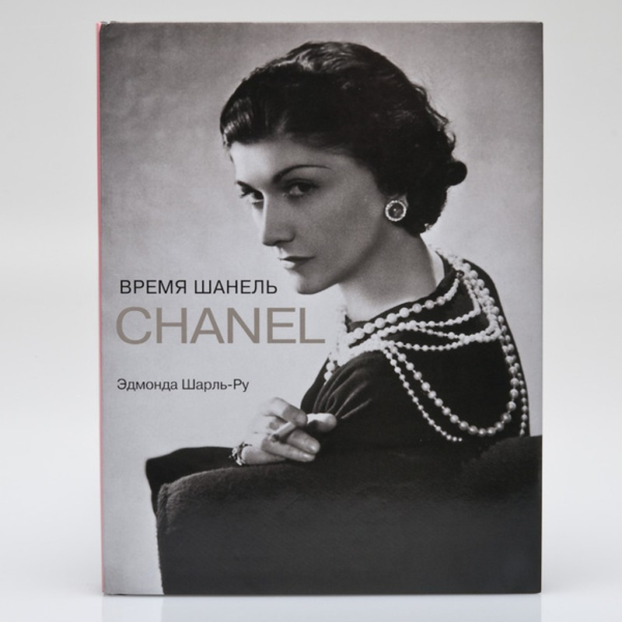
CHANEL - the master of prestige. Chanel is a brand that represents finest quality luxury goods which are usually very rare and reflect a very high class. Details and feminine accessories take a very important place in Chanel designs so the style becomes audacious, passionate, visionary and unique. Everything under Chanel labels must be perfect and classy

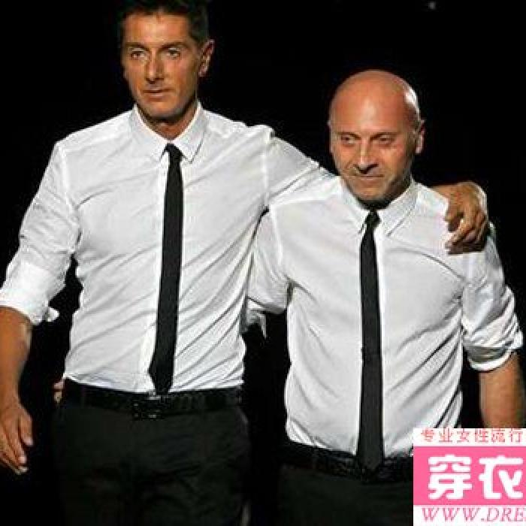
DOLCHE& GABANA- the master of fresh and funky designs. This brand is known for innovative ideas that make their designs look very modern and youthful. They use a wide palette of colors, materials and patterns that make goods suitable for urban and fast lifestyle people. The designs usually reveal all the advantages of women/men bodies so they look sexy and allure

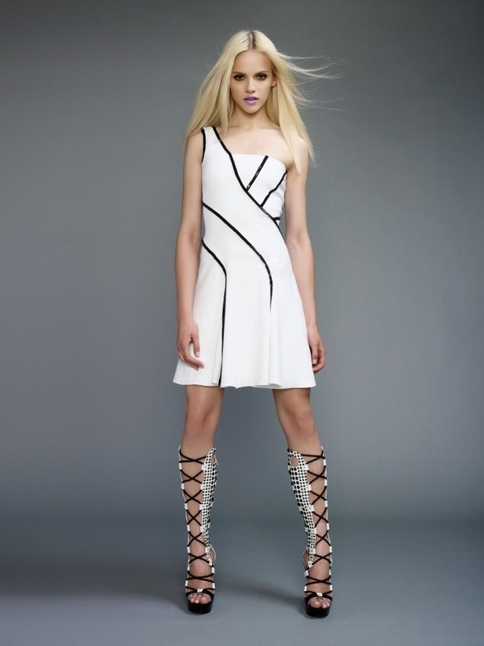
MISSONY - the master of geometrics, stripes, colorful patterns and wide range of fabrics. The numbers are incredible - there are at least forty colors and twenty different materials used in designing. All these exceptional features of Missoni fashion are often supplemented with Lurex and metallic elements which gives us a feeling of elegance and timeless chic.

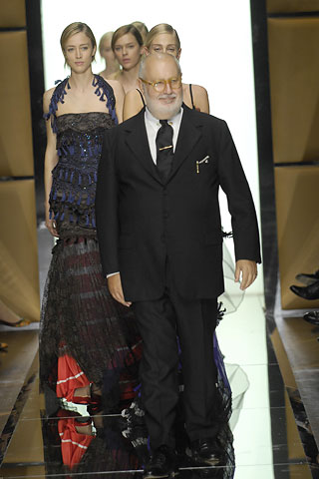
GIANFRANCO FERRE -the master of simple lines and practical apparel. All of his designs are informally elegant and in that way exceptional from the usual fashion. He is against all fashion trends and stylistic gimmicks. His designs usually are the synthesis of Eastern and Western cultures, with the main point being balanced forms, easy to wear, careful and relaxed designs which are acceptable for a very broad age audience.

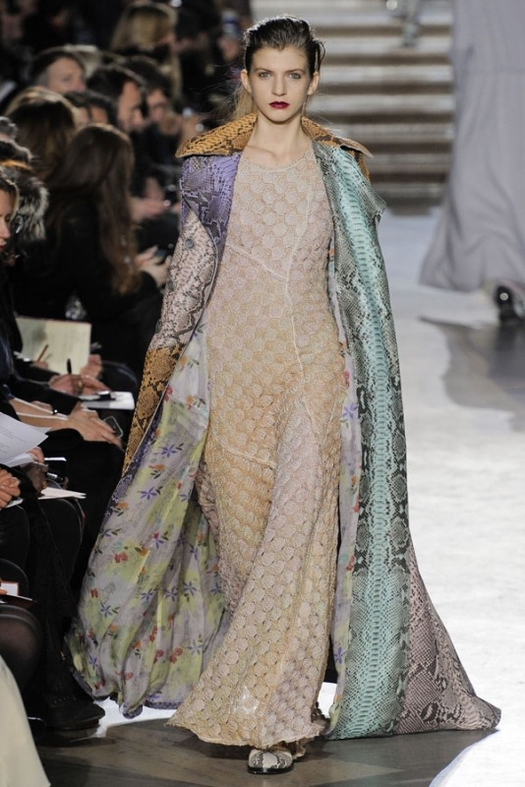
VICTORIA’s secret - the master of lingerie and underwear designing. For a long time Victoria's secret was orientated only at sexy underwear, bikinis, swimsuits, sleepwear, loungewear and similar intimate apparel for females, now it is going to expand and produce underwear for male audience as well. This brand is best known for high quality romantic, sexy, sensual, sophisticated, glamorous and sometimes even provocative collections. All runway shows of Victoria's secret get very much attention worldwide, and always include a performance with wings of angel, butterfly or even devil - that's the trademark.

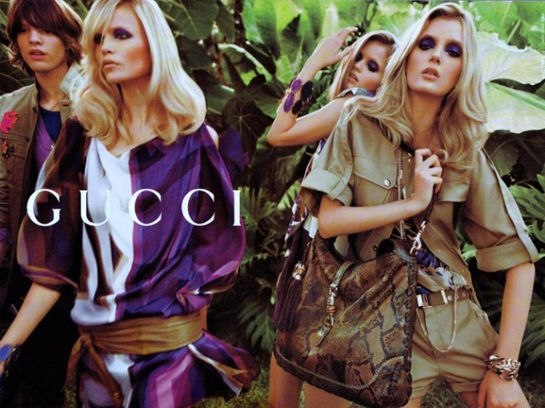
GUCCI - the master of splendid leather goods. Gucci is known for its luxury-good designs and is one of the best known names in prestigious designer tops. Though there are lines of clothing, sunglasses and all other accessories, best of the best from Gucci are leather goods - handbags and purses - which always have interesting details and unique taste.

5. Which designer do you like most of all? Why?

6. Get ready with presentation

СЛОВАРЬ СПЕЦИАЛЬНЫХ ТЕРМИНОВ

Dressmaking

arm-hole пройма
back спинка
baste сметывать
dressmaking establishment ателье женской одежды
fashion фасон, мода, стиль
be in fashion быть в моде
come into fashion войти в моду
follow fashion следовать моде
out of fashion выходить из моды
fashion-house дом моделей
fashion magazine журнал мод
fashion show показ мод
fashionable модный
garments одежда, платье
make a dress шить платье
pattern выкройка, лекало
press гладить, утюжить
remove удалять, стирать, спарывать
right side лицевая сторона
wrong side изнаночная сторона
shorten укорачивать
sew шить
stitch стежок, строчить
style стиль
stylish стильный
suit идти, хорошо сидеть, быть к лицу
try on примерять
wear носить
waist line линия талии

Kinds of skirts

Flared расклешенная
Full широкая
Gathered в сборку
just at knee до середины колена
just below the knee ниже колена
maxi макси
midi миди
mini мини
pleated в складку
straight прямая
tight узкая

Kinds of trousers

bell-bottomed брюки-клеш
full широкие
jeans джинсы
straghit-leg прямые
tight-leg узкие

Kinds of dresses

Dress: платье
ball dress бальное платье
best dress лучшее платье
evening dress вечернее платье
everyday dress повседневное платье
house dress домашнее платье
knitted dress вязаное платье
party dress вечернее платье
wedding dress свадебное платье

Kinds of clothes

Аpron передник
Blouse блузка
Cardigan кардиган
fur coat шуба
costume костюм
jacket пиджак. жакет
jeans джинсы
jumper джемпер
pull-over пуловер
raincoat плащ
shirt мужская рубашка
skirt юбка
suit костюм
tailored suit английский костюм
two-piece suit двойка
tree-piece suit тройка
sweater свитер
tunic туника
waistcoat жилет
uniform

Kinds of textiles and furs

blue fox песец
cloth сукно
cotton хлопок
crepe креп
crepe de Chine крепдешин
flax лен
fur мех
jersey трикотаж
leather кожа
linen холст, полотно
mink норка
nylon нейлон
polyester полиэстер
sable соболь
satin атлас
sheepskin овчина
silk шелк
silver fox черно-бурая лиса
synthetic синтетический
tweed твид
velvet бархат
velveteen вельвет, полубархат

Kinds of pockets

Breast нагрудный
Inside прорезной
Patch накладной
Side боковой

Kinds of sleeves

Kimono кимоно
Long длинный
Loose просторный
one-piece одношовный
raglan реглан
set in втачной
short короткий
tight узкий
three-quarter три четверти

Kinds of tools and sewing equipment

Bobbin шпулька
bobbin-case челнок
iron утюг
ironing board гладильная доска
chalk мел
measuring tape сантиметровая лента
needle иголка
scissors ножницы
sewing machine швейная машина
thread нить
thread a needle продевать нитку в иголку

Kinds of silhouettes and cuts

Classic классический
close-fitting облегающий
elegant элегантный
lightly-fitted слегка приталенное
loose-fitted свободный
semi-fitting полуприлегающий

Kinds of clothes

Clothes одежда, платье
best clothes лучшая одежда
children’s clothes детская одежда
fashionable clothes модная одежда
men’s clothes мужская одежда
old-fashioned clothes старомодная одежда
ready-made clothes готовое платье
smart clothes нарядная одежда
spick and span щегольская одежда
stylish clothes стильная одежда
women’s clothes женская одежда

ПРИЛОЖЕНИЕ:

Text A 1.Read the text and render it in English:

MY TAILOR
(By S. Leacock, "Perfect Lover's Guide and Other Stories")
He always stands there and stood these thirty years -in the back part of his shop, his tape moven about his neck, a smile of welcome on his face, waiting to greet me. "Something in a serge," he says, "or perhaps in a tweed?" There are only these two choices open to us. We have no others for thirty years. It is too late to alter now. "A serge, yes," continued my tailor, "something in a dark blue, perhaps."
He says it with all the gusto of a new idea, as if the thought of dark blue had sprung up as in inspiration — "a dark blue — Mr. Jennings" (this is his assistant), "kindly take down some of those dark blues."
"Ah!" he explains, "now here is an excellent thing." His manner as he says this is such as to suggest that by sheer good fortune and blind chance he has stumbled upon a thing among a million. He lifts one knee and drapes the cloth over it, standing upon one leg. He knows that in this attitude it is hard to resist him. Cloth to be appreciated as cloth must be viewed over the bended knee of a tailor with one leg in the air. My tailor can stand in this way indefinitely, on one leg, in a sort of ecstasy, a kind of lecal paralysis.
"Would that make up well?" I ask him. "Admirably," he answers. I have no real reason to doubt it. I have never seen any reason why cloth should not make up well. But I always ask the question as I know that he expects it and it pleases him. "You don't think it at all loud?" I say. He always likes to be asked this.
"Oh, no, very quiet indeed. In fact we always recommend serge as extremely quiet." . I have never had a wild suit in my life. But it is well to ask. Then he measures me — round the chest, nowhere else. All other measures were taken years ago. Even the chest measure is only done — and I know it — to please me. I do not really grow. "A little fuller in the chest," my tailor muses. Then he turns to his assistant. "Mr. Jennings, a little fuller in the chest — half an inch on to the chest, please". It is a kind of fiction. Growth around the chest is flattering even to the humblest of us. "Yes," my tailor goes | on — he uses 'yes' without any special meaning, "yes and shall we say a week from Tuesday, Mr. Jennings, a week I from Tuesday, please." "And will you please," I say, "send the bill to..." but my tailor waves this aside. He does not I care to talk about the bill. It would only give pain to both J of us to speak of it. The bill, as I say, is a thing that we ! never speak of. Instead of it my tailor passes to the ' weather. Ordinary people always begin with this topic. Tailors, I notice, end with it. It is only broached after the suit is ordered, never before. "Pleasant weather we are having," he says. It is never other, so I notice, with him. Perhaps the order of a suit itself is a little beam of sunshine.
Then we move together towards the front of the store on the way to the outer door.
"Nothing today, I suppose," says my tailor, "in shirtings?" "No, thank you." This is again a mere form. In thirty years I have never bought any shirtings from him. "And nothing, I suppose, in collaring or in hosiery?" This is again futile. Collars I buy elsewhere and hosiery I have never worn. Somehow if he failed to speak of shirtings and of hosiery I should feel as if familiar cord had broken. At the door we part. "Good afternoon," he says — "a week from Tuesday yes, good afternoon."
Such is — or was — our calm intercourse. I say it was, that is until just the other day. And then, coming to the familiar door, for my customary summer suit, I found that he was there no more. There were people in the store. And they told me that he was dead. It came to me with a strange shock. He seemed — he should have been — immortal.
They said the worry of his business had helped to kill him. I could not have believed it. It always seemed so still and tranquil weaving his tape about his neck and marking measures and holding cloth against his leg. Can a man die of that? Yet he had been going behind, they said, for years, His wife, they told me, would be left badly off. I had never conceived him as having a wife. But it seemed that he had a daughter too, — at a conservatory of music, and that ho himself played the flute.
As I went out I seemed to hear his voice still saying, "and nothing today in shirtings?"
I was sorry I had never bought any.
There is a deep moral in it. But I will not try to draw it. It might appear too obvious.
Read the text and render it in English.

Text B
AT THE TAILOR'S
(By J.B. Priestley )
I never walk into my own tailor's without feeling apologetic. I know I am unworthy of their effort. I am the kind of man who can make any suit of clothes look shabby and undistinguished after about a fortnight's wear. Perhaps the fact that I always carry about with me two or three fairly large pipes, matches, about two ounces of tobacco, a wallet, cheque-book, diary, fountain-pen, knife, odd keys and loose change, to say nothing of old letters, may have something to do with it.
I can never understand how a man can contrive to look neat and spruce and do anything else. Wearing clothes properly seems to me to be a full-time job, and as I happen to have a great many other, more important and more amusing things to do, I cheerfully bag and sag and look as if I had slept in my suits. I can say this cheerfully here, but once I am inside my tailors' I immediately begin to feel apologetic. They do not say anything, but there is mournful reproach in their eyes as they turn them upon their ruined masterpieces.
They have their revenge, though, when they get me inside one of their horrible cubicles, for a fitting. By the time
I have been inside one of those places ten minutes I have not a shred of self-respect left. It is worse than being at the barber's, and fully equal to being at the dentist's.
To stand like a dummy, to be simply a shape of flesh and bone, is bad enough, but what make it much worse are the mirrors and the lighting. At each side is a greeny-gold tunnel. I do not like all those images of myself. Wherever I look, I see a man whose appearance does not please me. His head seems rather too big for his body, his body rather too big for his legs. In that merciless bright light, his face looks fattish and somewhat sodden. There is something vaguely dirty about him. The clothes he is wearing, apart from the particular garment he is trying on at the moment, look baggy, wrinkled, and shabby. He does not pay enough attention to his collar, his boots. His hair wants cutting, and another and closer shave would do him good. In full face he does not inspire confidence. His profile, however, is simply ridiculous, and the back view of him is really horrible. And a woman and several children are tied to a fellow like that! Incredible that a man can take such a face and carcase about with him, and yet entertain a tolerably good opinion of himself! As I think these things, it is possible that I smile a little. That is what it feels like —- smiling a little; but immediately twenty images in that cubicle break into ghostly grins, produce wrinkles from nowhere, show distorted acres of cheek and jowl. And there is no looking away.
Meanwhile, the tailors themselves, so neat, so clean, so deft, are busy with the pins and the chalk. They are at home in these little halls of mirrors, and so look well in them from every possible angle of reflection. They pretend a certain subservience, but it is the idlest of pretences. They know —- and they know that I know — that I am but a shadow of myself, a puppet in their hands.

Notes

a full-time job — a job taking up a great deal of time
I cheerfully bag and sag — I cheerfully go around without paying any attention to my clothes that look baggy and have lost their shape

Text C
POOR MAN'S DAUGHTER
(After Gertrude Schweitzer)
Nora Swanson was always thinking of her two daughters, Milly and Frieda. Ever since they were born, she and Eric had planned to make their lives better, to give them all the things they themselves had never had. All their life long they had worked hard to make both ends meet. Eric worked at a plant, and they decided that Nora would take up janitress’s work in that fine building. At that time they thought it would be good if their daughters grew up among girls from rich families and went to a good school, a far better school than one in a workers' district.
Janitress's work was not easy. Nora had to keep a large house in good order. She got up early in the morning and was busy all day long cleaning, washing, dusting, sweeping, and doing hundreds of other things to earn her living and the small flat, of which she was very proud.
If Eric had been alive, it would not have been so difficult, but for a woman alone... If only there hadn't been that accident at the plant that had changed all their plans.
Milly had to go to work as a seamstress in a dressmaking establishment. She mastered sewing very quickly and was quite good at it. Now she was a real dressmaker and Nora was proud of her daughter.
Milly was a kind-hearted girl, but she came home tired. She had no friends in the building. Frieda, unlike her sister, had many friends there and was an active member of a girls' club.
That day, all the way home from the club meeting, Frieda was rehearsing. No, not any part in the play they had decided to put on. She was rehearsing her conversation with her mother. As soon as Nora learned that they were putting on a play, she would want her to put her sister, Milly, into it. But Frieda decided she would not give in. That play was to be put on by club members only, and what would the girls say when they learned that her sister was a dressmaker?
Nora had good reason to want Milly to take part in something with other girls. Milly stayed in her room too much making drawings or busy with her sewing. Once or twice, Nora had already started telling Frieda to ask Milly to join the club.
"Is that you, Frieda?" Nora's voice came from the kitchen as the girl opened the door.
"Yes, mother. Let me help you lay the table."
"Put the soup plates on the table," mother replied. "How was your club meeting?"
"Fine," Frieda said. "Why are we having soup on so hot a day?"
"Because you must always have soup once a day," answered Nora.
"We're putting on a play," continued Frieda.
"Good. What kind of play?" inquired Nora.
"It's a costume play. I'm going to wear a hoop skirt."
"Don't forget the soup spoons, Frieda. How many girls will be in the play?"
"Only four of us will have speaking parts. But everybody in the club will be busy." Then the girl raised her voice to make the point clear, "We're going to make our own costumes and our own scenery."
"Sounds as if you'll be busy. The butter is in the refrigerator. Milly would be glad to help you." Nora knew when to raise her voice, too.
"I know she would, mother," came from Frieda, "but we aren't going to need any help. It's a club play for members only."
Mother took the plates. "Will you help me with the meat, Frieda? Milly stays alone by herself too much. I think a club like yours would be very good for her. Is there any sugar in the sugar-bowl?"
"Yes, mother."
"Good! Let's ask the girls to come and see Milly's drawings. They will see at once that she can design the dresses and scenery for your play. As for hoop skirts, why, she..."
"Mother, please! When I said 'yes' I meant there was sugar in the sugar-bowl. Grace is going to make the scenery. Audrey is going to make the hoop skirts."
"Oh, well. I think Friday night will be a good time to ask the girls to come. Tell Milly, will you, dear?"
"Tell Milly what, Mother?"
"Tell her to come to dinner."
In the girls' room Frieda found her sister, needle in hand, sewing. She was wearing jeans and sweater that fitted her very well. "Dinner's ready," Frieda said.
"Good!" Milly answered, "I'm hungry and tired and happy, and that's the right time for dinner."
"Why are you happy, Milly?"
"I've finished Mother's dress. It's to be a surprise." Frieda wanted to see the dress, but Milly replied, "Wait until after dinner, Frieda. I want you to take time for a good look."
So the girl had to wait to see the dress. It was a beautiful two-piece suit with a blouse to match it. The jacket had four buttons. The sleeves were long. The skirt was slightly pleated and had a zip-fastener.
"And you've done that without a single fitting!" Frieda exclaimed. "Mother will love it! She'd love a dress like this even if you hadn't design it and made it yourself. Nothing could please her more."
"One thing could please her more," Milly said. "All the time she tells me to be like you."
"Like me? Why?"
"Oh, you know. You have many friends. You are a member of a club. You are always with people. I am more often alone by myself. Mother wants me to join your club."
"I know," the younger sister said. "Mother wants me to ask the girls to come and see your drawings. She thinks you can help us make hoop skirts and scenery for the play."
"Of course, I can."
Frieda turned cold. Did Milly want to be with her friends, in her club? That was impossible.
One day Milly came home later than usual. Her face was bright with colour, the eyes shone. She went to the kitchen where Nora was preparing supper, pushed her yellow hair back from her face and sat on the edge of the kitchen table. She was smiling a far-away smile and singing to herself.
"I met this boy," she said, "Buzz Trevor, and he walked me home. On the way we stopped for a cup of coffee. We sat there a long time." "She was not telling it," Nora thought, "she was reliving it."
"We just talked and talked."
"Why hadn't he come in, so that I could meet him?" Nora inquired.
"I don't know. He had to get back." She looked out of the window.
"He said he'd call soon and we'd have a ride."
"You should have asked him to come in," Nora said. Milly said nothing, but ran into the bedroom and closed the door. Nora sat down. She thought she knew why Milly had not asked this Buzz Trevor in to meet her. She did not want him to know she was the daughter of the janitress. She hadn't told him that she was a dressmaker. In that she was just her younger sister.
The telephone rang in the hall, and Milly ran from the bedroom to answer it. In a minute she came and stood in the kitchen doorway. "Mom," she said. "I'm sorry. I don't know what got into me." Nora smiled. "We'll not speak of it," she said. "Sit down and have your supper."
Milly moved slowly to a chair. "That was Kathy Fillmore on the phone," she said. "She's giving a party Saturday night." "And are you invited?" Nora asked. "Kathy Fillmore has invited you to this party?"
"Buzz Trevor told her he wants me to be his date."
Nora began to eat. She did not speak for a moment. Buzz Trevor He had no face, no form, only a name that Milly repeated. He could be a bad boy, and Nora would not know it. There would be nothing she could do.
Just as Milly began to eat, the telephone rang again.
"That was Buzz, calling," Milly said as she came back. "He'll come after me Saturday night."
Nora smiled. "I'm glad," she said. "I'll meet him then."
"Well," Milly said and looked away. "I told him not to come in. I said he should honk, and I'd come out."
"Oh," Nora said. "I see," They did not say very much during the rest of the supper. They did not say much when they washed the plates together, though usually this was the time when they talked most.
"Milly must have a new dress", Nora thought. "When a girl is young and she goes to her first party with the first boy that she really likes, she should have a new dress, Nora was sorry she had no money saved to buy Milly n new dress.
The following days Milly came home as early as she could and sat up until almost two, altering the blue dress, When it was finished, it did not look like the same dress, It was tight-fitting, open at the neck, with a straight skirt The sleeves were short, and it fitted Milly wonderfully. The belt was of a darker colour and it matched the dress very well.
"This Buzz will be looking at you only," Nora said, "You look... If only Papa could see you."
In her heart Nora was proud of her daughter's skillful hands that had turned the dress into something that looked no worse than the dresses worn by the girls that came from rich families.
When Milly was gone, Nora sat down and turned on the radio. But she was not really listening. She was thinking about her daughter at the Fillmore's party. Her daughter, beautiful even in her altered dress, yet not like the girls who had mothers they were proud of.
After a time, she fell asleep and then woke suddenly. The sound of a man's voice came to her from the radio, "...driven by Busby Trevor, nineteen, went out of control and hit a tree," the voice said. "The names of the teenagers in the car are not yet known..."
Nora turned off the radio. Her eyes found the clock. It was almost twelve-thirty. You could not telephone anybody at such an hour. Yet, she went out into the hall and looked up the number. Almost as soon as the ringing started, the receiver at the other end of the line was taken.
"Hello, Mrs. Fillmore?" Nora said in a voice that was not her own. "This is Mrs. Swanson, Milly Swanson's mother. I heard on the radio about the accident. Do you know, please, what happened? Do you know... was my Milly... was she in the car?"
It took Mrs. Fillmore a second to answer. Nora thought the silence would never end. "Milly was with the Trevor boy, Mrs. Swanson. They left with six others. But it may be all right. The report said none of them may be hurt. They don't know yet." "I must go to Milly," Nora said.
"Be a little patient if you can," Mrs. Fillmore replied. No news has come on where they've been taken. You will be informed at once."
Nora put down the receiver and went inside and into the darkness of the girls' bedroom. She sat down on Milly's bed. Frieda was sleeping quietly in her bed.
There was some noise at the outside door, and Nora ran into the hall.
The door of the flat opened. Milly stood there, Milly and a boy.
"Milly," Nora could hardly say. "Are you all right?" "Oh," replied Milly. "They're all right. No one was hurt. That silly Buzz..." "Mom, you didn't think I was with them, did you?"
Nora lowered her head.
"Oh, no!" exclaimed Milly. "I didn't go. I thought Buzz was taking me home. But when we got outside to the car, I saw how Buzz was and I wouldn't get in."
Milly laughed and turned to the boy. "This is Dave, Mother. We had to walk all the way home because the last bus had gone. That's why we're so late."
The boy's hand was strong in Nora's, a working-man's hand, somewhat like Eric's. "I'm sorry you were upset," he said.
When he was gone, Nora sat down. "I'm sorry that you were upset, Mother," said Milly. Nora smiled in the darkness. "How foolish she had been," she realized She was sorry for the mother of Buzz and the mothers of those who had gone in the car with him.
In Frieda's club, they were having problems. One problem was the hoop skirts. Still unfinished, they looked as if Audrey would never finish them. If she ever finished them, they were sure to look as if they were made of bedroom curtains.
One day Frieda opened Milly's closet where Milly usually kept her dresses. This time 'it was empty except for one beribboned hoop skirt wonderfully sewn.
"Oh, Milly," she cried, "how did you ever know that the costumes we made were really bad?"
"Thank Mother for that," she answered. "She asked you the right questions. I just listened."
"But why did you do this for me? Why, after I didn't help you to get into the club?"
Milly looked at her sister as if she didn't think the girl would understand what she was about to say: "You're my sister, that is all. We're in the same family. That's good enough."
"I understand, Milly. I was wrong. It isn't chance that makes a family. It's much more than that. And it isn't important what you do, it's how you do it and that you do it. I'm sorry." And then Frieda continued. "Milly," she said, "the trouble with my club is that everybody in it is careless. We must have somebody who can get things done right. If I call the girls right now...well...will you join our club?"
Suddenly Frieda realized that the girls from 'good', rich families were not important at all. She was proud of her sister, a really good working-girl, coming from a working family, who could do things and do them right. She was proud of her, for she understood that it was work that made a man. Now she wanted to be like her elder sister.

Notes
janitress — уборщица
she would not give in — она не уступит
I'm going to wear a hoop skirt. — На мне должно быть платье с кринолином.
raised her voice — повысила голос
she can design the dresses and scenery — она может придумать фасоны платьев и сделать эскизы декораций
two-piece suit — юбка и жакет
was slightly pleated — была заложена в мелкую складку
zip-fastener — застёжка "молния"
was reliving — вновь переживала
date — партнёр
he should honk — он просигналит
but I knew he wasn't much — но я знала, что ничего особенного он не представляет
poster — афиша
she was ashamed — ей было стыдно

CПИСОК ИСПОЛЬЗОВАННОЙ ЛИТЕРАТУРЫ:

1. Буксбаум Г. Законы стиля. История моды 20 века

Амфора 20009 г.

2. Блохина И. Всемирная история костюма.

Харвест 2007 г.

3. Володин В. Мода и стиль.

Аванта 2006 г.

4. Васильев А. Этюды о моде и стиле.

Альпина нон-фикшн 2011 г.
5. Манси Е Английский язык
Киев «А.С.К»2000г
6.Стивенсон Н. История моды в деталях
Экма 2011 г.
7. Тэтхем К. Fashion Drawing Course
Рипол Классик 2006 г.

8. Уайзер ГМ, Фоломкина СК, Климентенко АД

Дидактический материал по английскому языку для СПО

Просвещение 2000г

9.Хайвэл Д . 100 новых дизайнеров одежды
ISBN 2007г

10. Эдрих М. Загадочная Коко Шанель
11. WWW.lot books.ru|shop

